**PROJECT REPORT**

**TEAM LEADER:PARAMESWARI.K TEAM ID:NM2023TMID20975 TEAM MEMBERS: 1)PAVITHRA.R 2)PRABHAVATHI.E 3)PRIYADARSHINI.K**

**OVERVIEW:**

**I have complete my project with my team. My topic is retail management using sales force in this project have 8 milestones .As we move past each milestone, we get to know it better.**

**PURPOSE:**

**Retail is one of the important perspectives in a chain of distribution channels. It is the business to consumer channel. Here consumers can directly purchase the products goods and merchandise from the retail marts. It is fulfills the needs and requirements of consumers.**

**2.PROBLEM DEFINITION & DESIGN THINKING:**

**2.1 DATA MODEL: EMPATHY MAP**

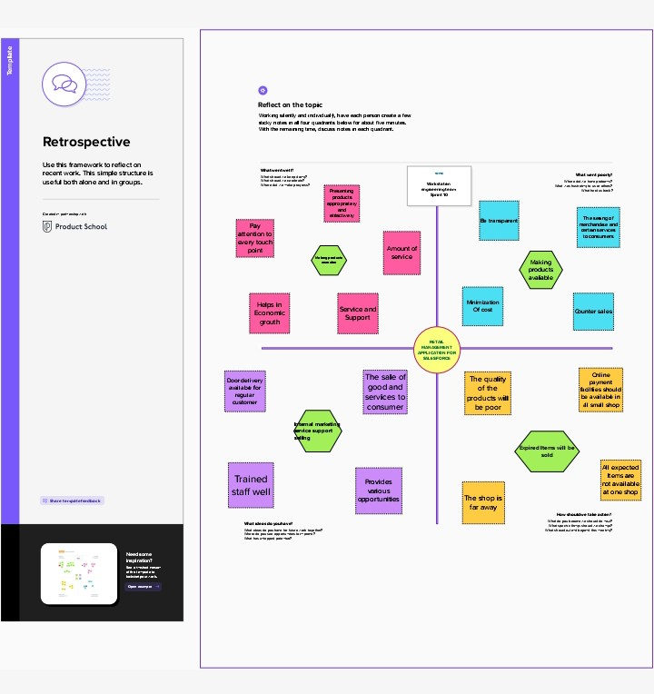

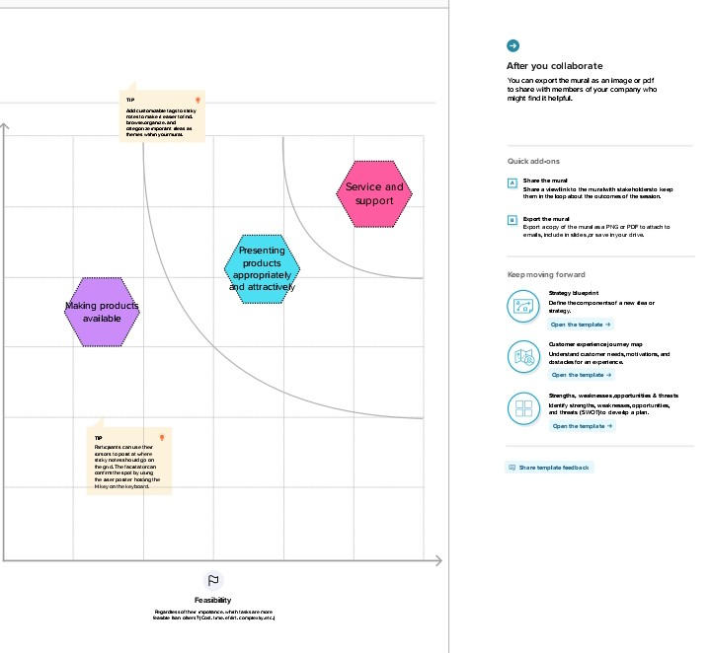

**ACTIVITY & SCREENSHORT:**

**MILESTONE:1**

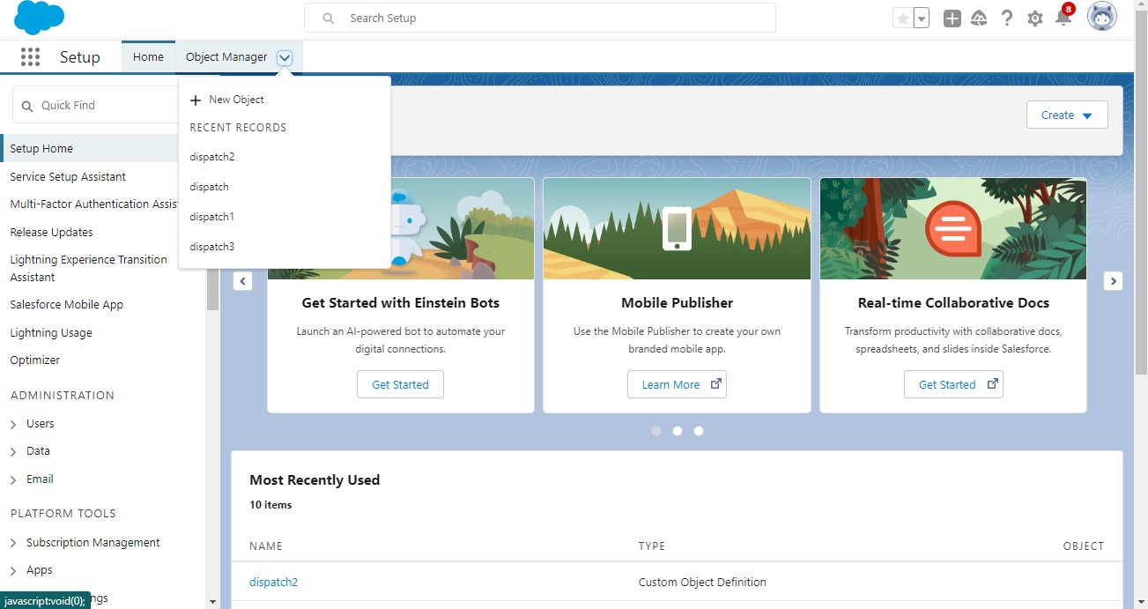

**MILESTONE:2**

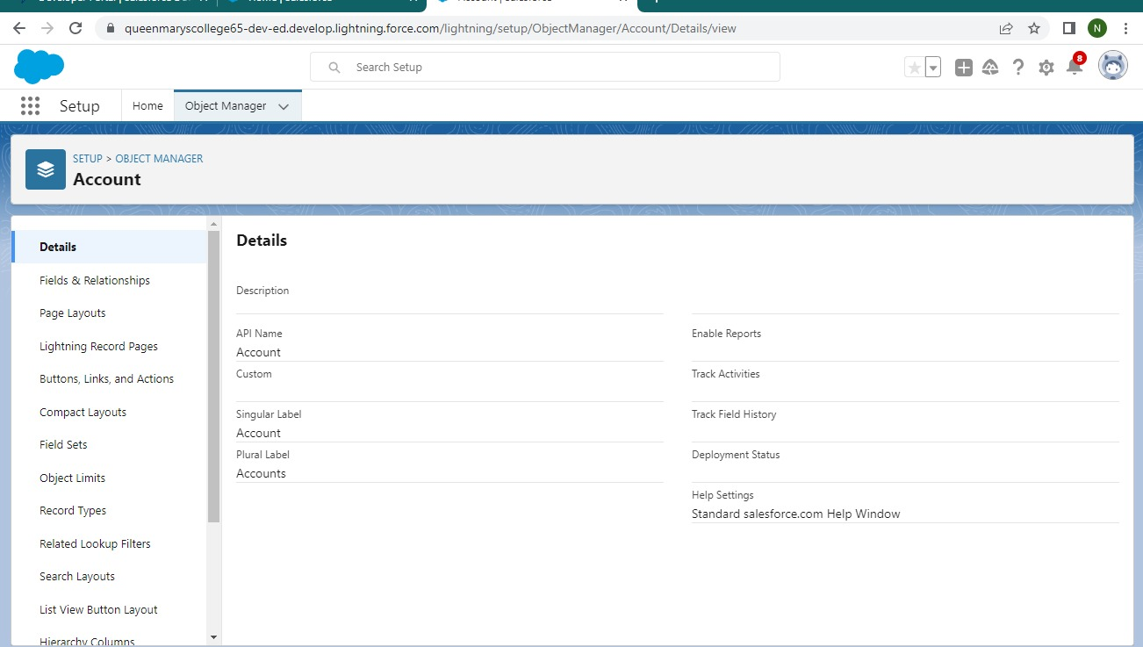

**MILESTONE:3**

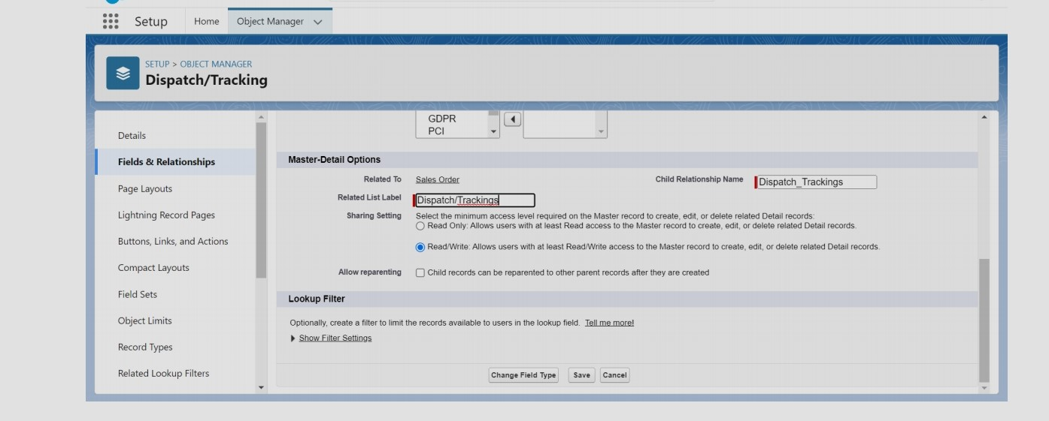

**ACTIVITY 2**

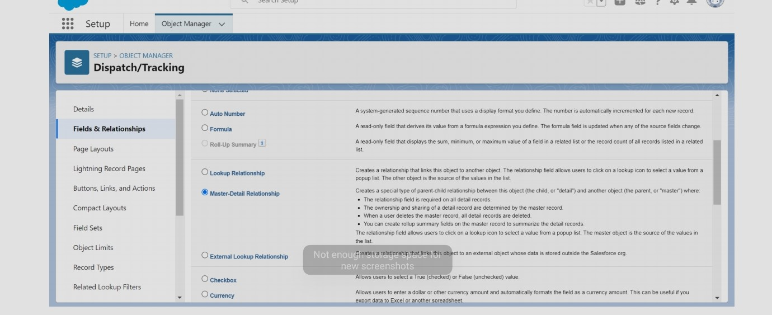

**MILESTONE:4**

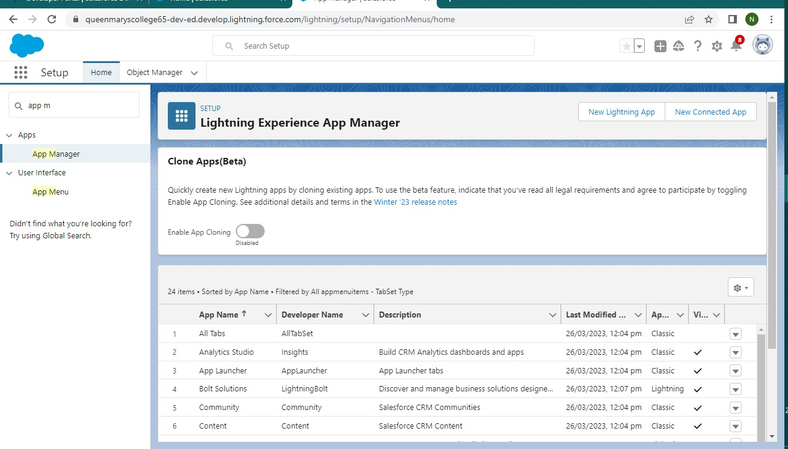

**MILESTONE:5**

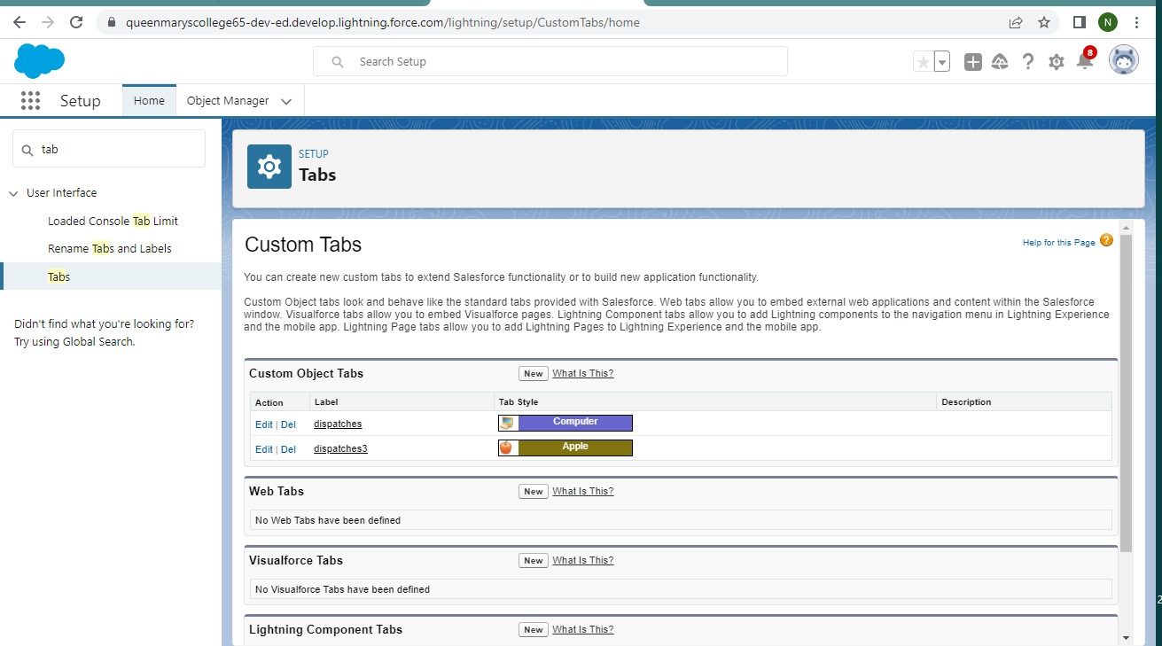

**MILESTONE:6**



**MILESTONE:7**

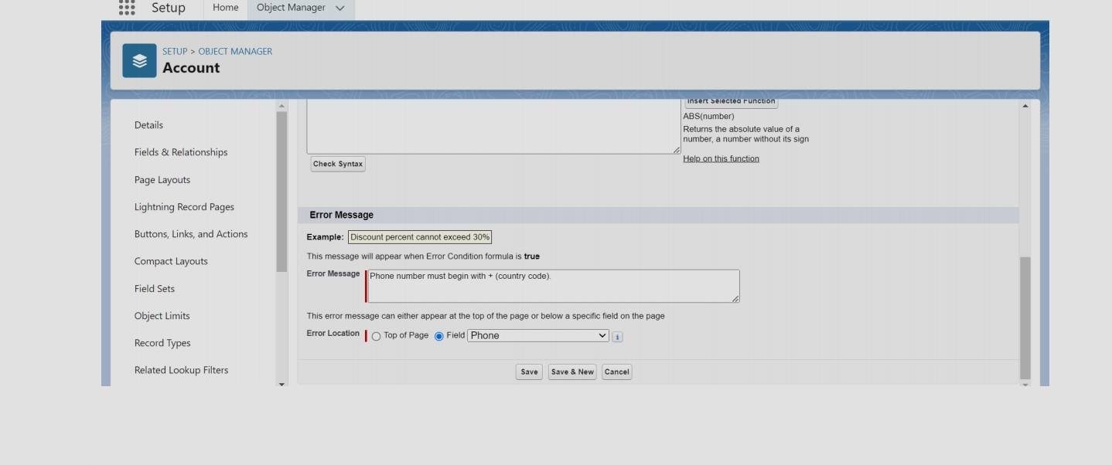

**MILESTONE:8**

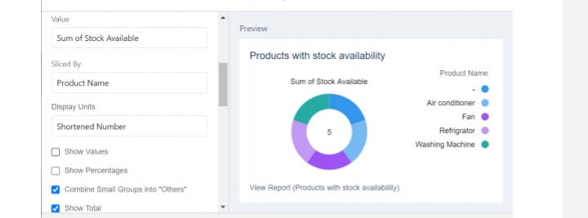

**ADVANTAGES & DISADVANTAGES:**

ADVANTAGES:

**In addition to the flexibility, salesforce is easy to use. Even if you don’t have an in –house IT team, you will be able to implement changes at an administrative level.**

**Salesforce’s learning program, called trailhead, will take you from simple user to administrator in an understandable way.**

**In this learning program, you will be able to learn about various modules**

**Flexibility is a key competitive advantage of salesforce. salesforce can be used according to business requirements.**

**DISADVANTAGES:**

**Companies with a very large customer base sometimes have to integrate external databases. This further leads to additional costs and data storage issues.**

**Individually developed plugins must be continuously maintained because they should be checked for functionality after each salesforce update.**

**APPLICATIONS:**

**Sales management and retail management are using for salesforce.**

**CONCLUSION:**

**Finally have complete my team project its very interesting and improve my knowledge.**

**FUTURE SCOPE:**

**Future is always on salesforce hand and future is job application system, retail management system usage projects are available for future.**

**THANK YOU**

**No table of contents entries found.//**